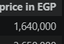
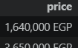
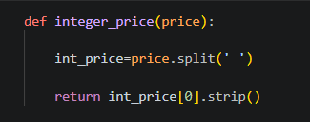
1-Remove "EGP"using that fn, the i/p, o/p
after apply . Explain: split(), used to create list separated by space
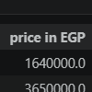
Then price[0]=1,640,000. Next line return the number without "EGP", also used "strip()" to delete any space written by mistake as Ex " 1,640,000 EGP", will remove the space in start

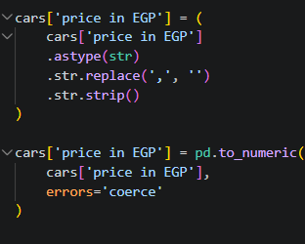
2-change "Price in EGP" to int: i/p o/p
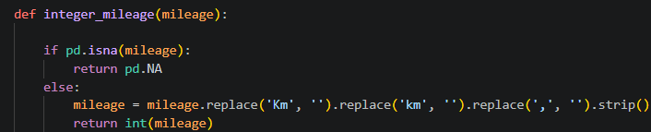
1st part "astype" to check it is string, "replace" to remove ", 2n part use "pd" to conver string to integer, that "pd" will not able to convert "1,25,00". Error = "coerce" to let any srtrange value change to "Nan"
3-convert "mileage" Cl to "mileage in KM" int Col, here simpler by fn, and apply "replace" successively in one line, apply
4-Convert "year" to "numeric": here "astype" used with panda to convert from data type to another, used "int64" bcz it is allows "NA" exist without generating error, while "int" will create error if "NAN"
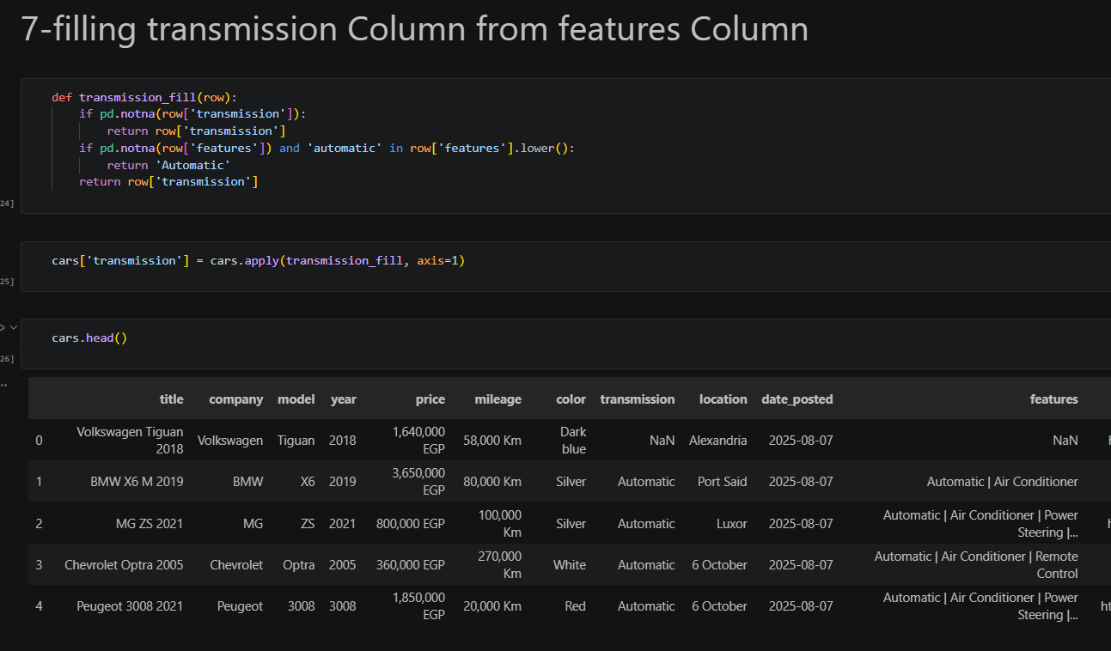
5-changing date posted to date/time type
6-filling transmission col from features col: fn applied to each row, if transmission "notna" leave same, next "if" feature notna also "automatic" word exist, return "automatic", if not both, leave as it is
Then apply fn. Note that "axis=1" bcz we need to send to the fn the whole row, then fn could replace from one col to another, if not "axis=1", fn won't see the other col's in the same row, will see 1 value in the row
7-Year Outlines: Sort Ascendig of Col "year"with dropping "NA" and remove repetition
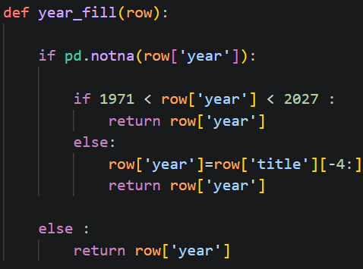
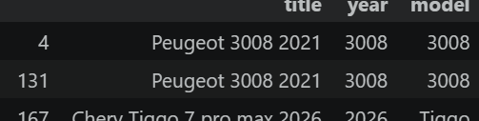
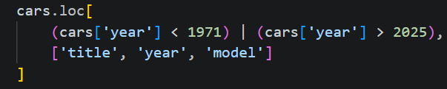
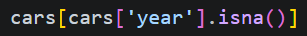
-here: show df with only rows in which year value is "na", Drop them, now "isna" will show blank
-show rows with outlines
-here will fill year if outlier with the model year shown in title, then apply
-convert to numeric
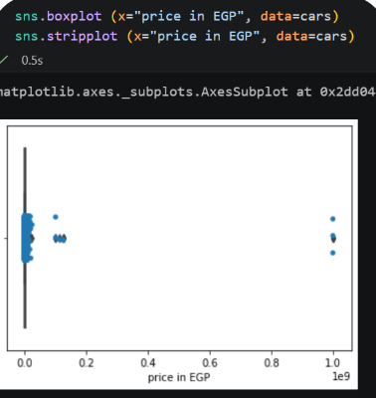
8-Price outliers: -check by plotting: "box plot" show median and Q1,2,3. While "stripplot" show each car as a single point
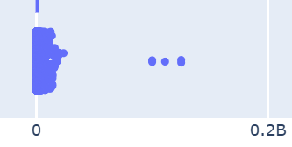
-"plotly express": "box" points=all to show all cars
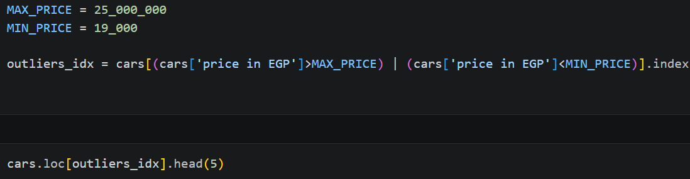
-importing "detect_outlier "datasist"
-setting Max, Min for Outliers, locating ".index"
then removing "np.nan"
9-KM outlier: "cars[mileage in KM"]>1000,000" will return true of the values whose meet that criteria
Cars.loc: will locate the rowshas true.
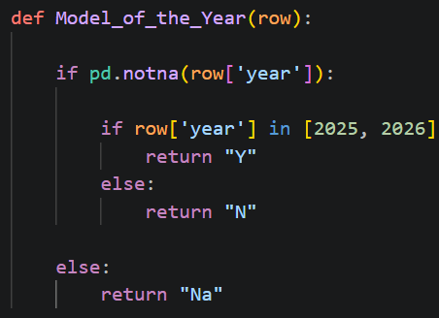
"mileage in KM" will apply the after "=" value only to that Column in specified rows, not deleting the whole row, which give me the chance to fill that Nan after that
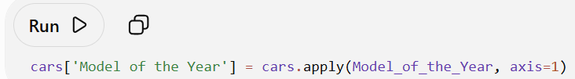
10-Creating Col "Model of year": meaning of "axis=1" when applying fn, means for that df, send data to the fn row by row, apply that fn to each row
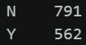
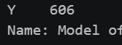
-To check Col created correctly: should find count same as cnt of year Col of same value, also must see all "Y"
-to show if not correct, let's assume u put "2024"
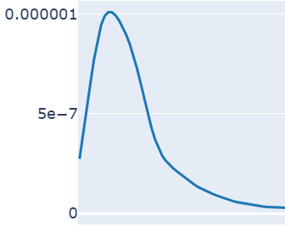
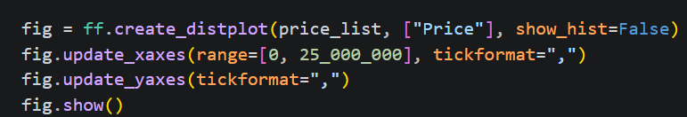
11-Univariate Analysis: "X" mileage, "Y" by default will be cnt, "nbins" show resolution, as ++ more detailed shown
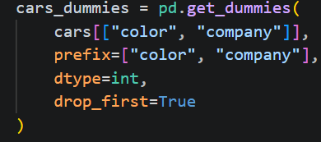
12-Bivariate Analysis
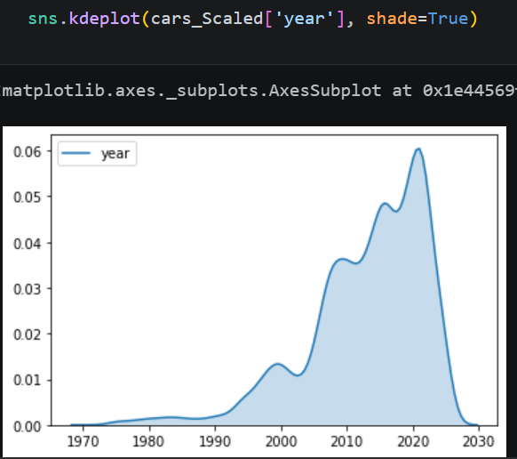
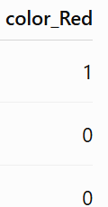
13-Encoding: "get_dummies" will convert following Col's to "0001",……, "prefix" will let Col "color_red", "company_BMW". "dtype=int"
14-adding the encoded df to original df

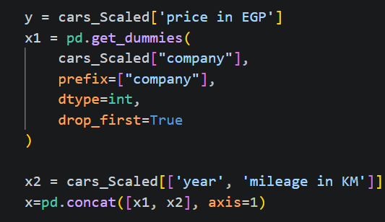
15-Scaling and splitting: "kdeplot" will show distribution of values, here we draw that before scaling to see scaling effect after applied, do same for "price, KM"
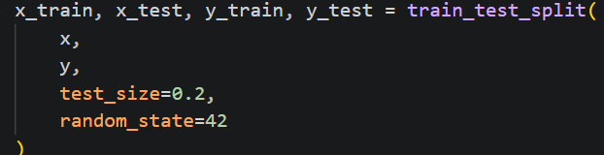
-defining x, y after encoding categorical data, split train test
Note that the encoded cells not need scaling as it is "0,1" only
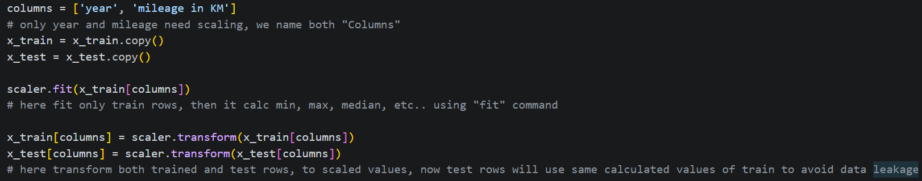
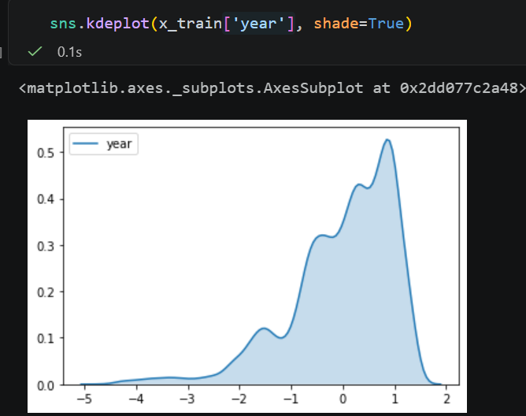
-Scaling Step: define "columns" as only Col need scaling, fit for training only, to calc min, mx, med of scaling, then transform for train and test, here test rows will use o/p of train rows fit
-display "kde" plot after scaling for year, compare with the above fig, show scaled value with same distribution

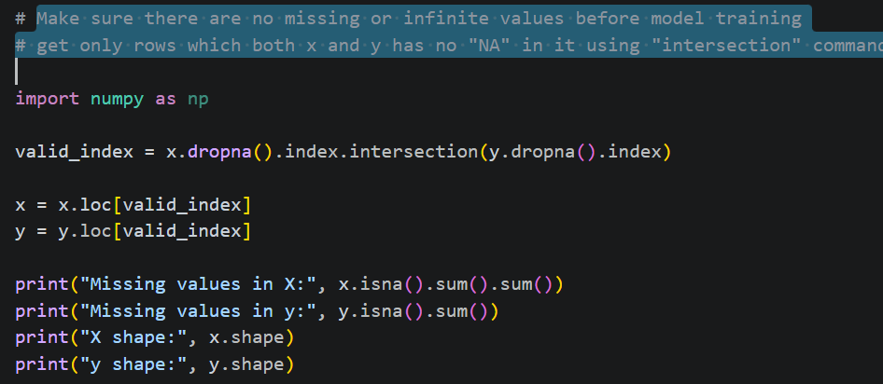
## Machine Learning
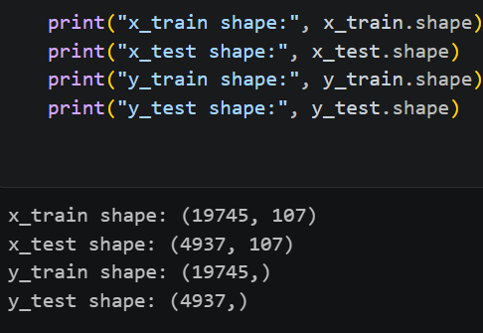
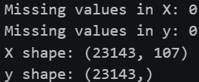
16-Removing "NA": her checked "inf", not found any, checked "na" found a lot, then created df "valid index" which have only the rows at where both x, y at same time not "Na"
17-Checking data shape: here we check if i/p traind and o/p train has same row cnt

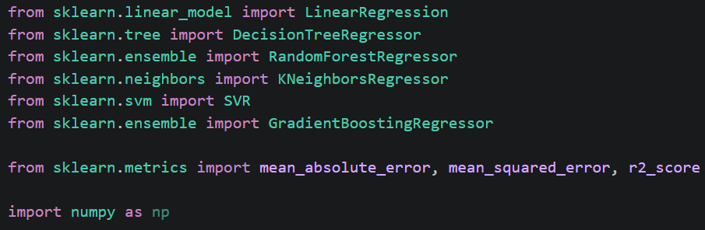
18-Imprting libraries needed for Regression

